Task 1: Normal Mapping
Consider that we want to render a piece of cloth, or a stone wall , or a water or any type of object with allot of irregularities. Having our 3D artist create such an object will not be viable since it will take him allot of time, and the result will have allot of vertices, thus it will occupy allot of memory in the GPU, generate cache misses because of his huge size and increase the amount of traffic between CPU and GPU.
We can create the illusion of irregularity by altering the way the light is bounced off the mesh. In image 35 the effect of normal mapping is illustrated.

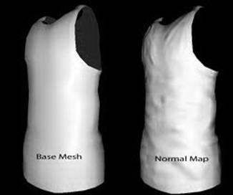
Image 35 : Normal Mapping Example. Both meshes have the same number of polygons.

In Image 35 the 2nd mesh has a normal map applied to it. A normal map is nothing more then a texture, but instead of a texel carrying the information of a color, it will carry the direction of a normal. Image 36 shows how the normals stored in a normal map looks like.
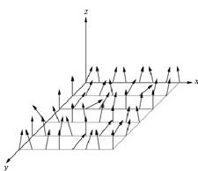
Image 36 : Normal Map

So it seems all we have to do is instead of using the interpolated normal in the fragment shader, we take the normal from the normal map texture. While this is roughly the idea, there’s still a problem we must solve.
The normals are all relative to texture space, while the light of the scene is relative to world space. We need to bring either the texture to world space, or the light to texture space to get the correct result.
To change from world space to texture space we need to compute the Tangent Binormal (or Bitangent ) Normal matrix.

Computing the TBN Matrix
Rules to keep in mind:
- the TBN matrix must be calculated on fragment shader, not on vertex shader because it doesn’t interpolates well (it loses its orthonormal property during interpolation);
- The TBN matrix can transform a vector from:
  - tangent space to local space (if the TBN is constructed using normal, binormal and tangent expressed in local space);
  - tangent space to world space (if the TBN is constructed using normal, binormal and tangent expressed in world space).
- it’s simpler to perform the lighting calculations into world space (you have camera already in world, lights already in world). So, you will need to transform the normal read from the normal map texture (which is expressed in tangent space) to the world space.

TBN matrix
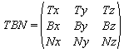

To move any object to the texture space we will need to multiply that object’s matrix with the inverse of the TBN matrix. Luckily the TBN matrix represents the axis of a coordinate system, therefore the vectors described by the TBN matrix are orthogonal, so it’s inverse is it’s transposed.
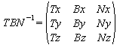

Multiplying with the inverse of the TBN matrix will bring an object from world space / local space into texture space .

In image 37 the difference between the lighting models is shown :
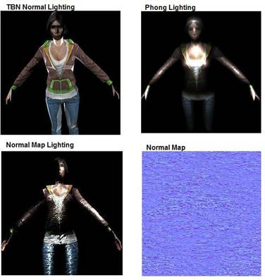
Image 37 : 3 Lighting approaches.

In the first image the normal is calculated from the TBN matrix of the vertex, resulting in flat illumination across surfaces. The Phong lighting model is smooth , with a gradual falloff . On the 3rd lighting model we applied the normal map shown on the right and after that we applied the Phong lighting model. Notice that the woman seem to have waves on her. This is an illusion made by the way the light bounces off her.

A vertex structure that will have enough data to render a model with normal mapping would be as follows :

struct Vertex
{
Vector3 position, normal, bitangent, tangent;
Vector2 UV;
}

From the vertex structure we can notice that there is only one set of UV coordinates. The normal map and the object map will have to be identical in dimensions, and each normal mapped object should have his own normal map to achieve the desired result.
If you look closely on Image 37, you will notice that there still are a lot of rough edges on the Normal Map Lighting model. Also some faces are incorrectly illuminated. That’s because the Normal Map applied to the object was meant for an Object shaped as a Plane, not as a woman. Still the effects of the normal map are noticeable.
Now that we know the vertex shader structure, we can finally write down the pseudocode for the vertex and fragment shaders :

Vertex Shader
attribute vec3 a_positionL;
attribute vec3 a_tangentL;
attribute vec3 a_bitangentL;
attribute vec3 a_normalL;
attribute vec2 a_UV;
uniform mat4 u_WVP;
uniform mat4 u_W;
varying vec3 v_tangentW;
varying vec3 v_bitangentW;
varying vec3 v_normalW;
varying vec2 v_UV;
void main()
{
gl_Position = u_WVP * vec4(a_positionL, 1.0);
v_normalW = normalize((u_W * vec4(a_normalL, 0.0).xyz);
v_tangentW = normalize((u_W * vec4(a_tangentL, 0.0).xyz);
v_bitangentW = normalize((u_W * vec4(a_bitangentL, 0.0).xyz);
v_UV = a_UV;
}

And the fragment shader pseudocode will be :
varying vec3 v_tangentW;
varying vec3 v_bitangentW;
varying vec3 v_normalW;
varying vec2 v_UV;
uniform vec3 LightDirection;
uniform sampler2D u_normalMap;
uniform sampler2D u_objectTexture;
void main()
{
vec3 normal = texture2D(u_s_texture,v_UV).xyz;
mat3 TBN = mat3(normalize(v_tangentW),normalize(v_bitangentW),normalize(v_normalW));
vec3 normalW = normalize(TBN * (2.0 * normal - 1.0));
float diffuse = max(0.0, dot(-LightDirection,normalW));
vec4 color = texture2D(u_objectTexture,v_UV);
gl_FragColor = vec4(diffuse * color.xyz,color.a);
}

u_normalMap texture can be made from based texture by NormalConverter tool in same folder of this file.

For more reference, you can see:
https://docs.gameloft.org/3d-training/#Normal_Mapping

---------- Try your best bro ---------

